16th July 2018

**Michelisz fights back with win at WTCR Race of Slovakia**

Norbert Michelisz topped off an action-packed WTCR Race of Slovakia weekend with his first win in the WTCR – FIA World Touring Car Cup which has Japanese premium tyre manufacturer YOKOHAMA as exclusive tyre supplier, following a thrilling Race 3 at a sun-baked Slovakia Ring.

Team OSCARO by Campos Racing’s Pepe Oriola and Gabriele Tarquini also claimed victories, taking a win apiece on Saturday. Oriola and Michelisz, who partners Tarquini in the Hyundai-powered BRC Racing Team, are winners number 10 and 11 of the season respectively, while Oriola’s success for Cupra in Race 1 means six customer racing brands have won races in 2018.

Tarquini heads into the summer break at the top of the standings, albeit a slender three points ahead of Yvan Muller with Michelisz firmly in contention in third, closely followed by Yann Ehrlacher (ALL-INKL.COM Münnich Motorsport Honda Civic Type R TCR) and Audi Sport Leopard Lukoil Team’s Jean-Karl Vernay, who beat Tarquini to second place in Race 1 behind Oriola.

In a weekend of firsts, Norbert Nagy scored his and Zengő Motorsport’s maiden WTCR podium with second in Race 2, sandwiched by his boyhood heroes Tarquini and Muller. Fabrizio Giovanardi claimed Team Mulsanne’s first points with fifth in Race 1 in his Alfa Romeo Giulietta TCR by Romeo Ferraris. New team-mate Kevin Ceccon was sixth in Race 3 on his championship debut. Denis Dupont took his first points with eighth in Race 2 in his RACB National Team Comtoyou Audi, while Zsolt Szabó scored for the first time, finishing P10 in Race 3.

Teenager Benjamin Lessennes was the best Honda driver over the weekend with fifth in Race 2 for Boutsen Ginion Racing, one place ahead of John Filippi. Czech wildcard entry Petr Fulín, the FIA European Touring Car Cup winner from 2017, charged from P16 to fifth in Race 3, but it was a weekend of frustration for Slovak Mato Homola, who was out of the points in all three races.

Frédéric Vervisch secured the final podium of the weekend, after fending off World Touring Car champion Thed Björk for third in Race 3 by 0.002s in a thrilling photo-finish. The results of Races 2 and 3 remain provisional pending an ongoing appeal process.

The series will resume on the 28-30 September with the first Race of China-Ningbo.

Current Driver standings:

1. G. Tarquini 202pts
2. Y. Muller 199pts
3. N. Michelisz 176pts

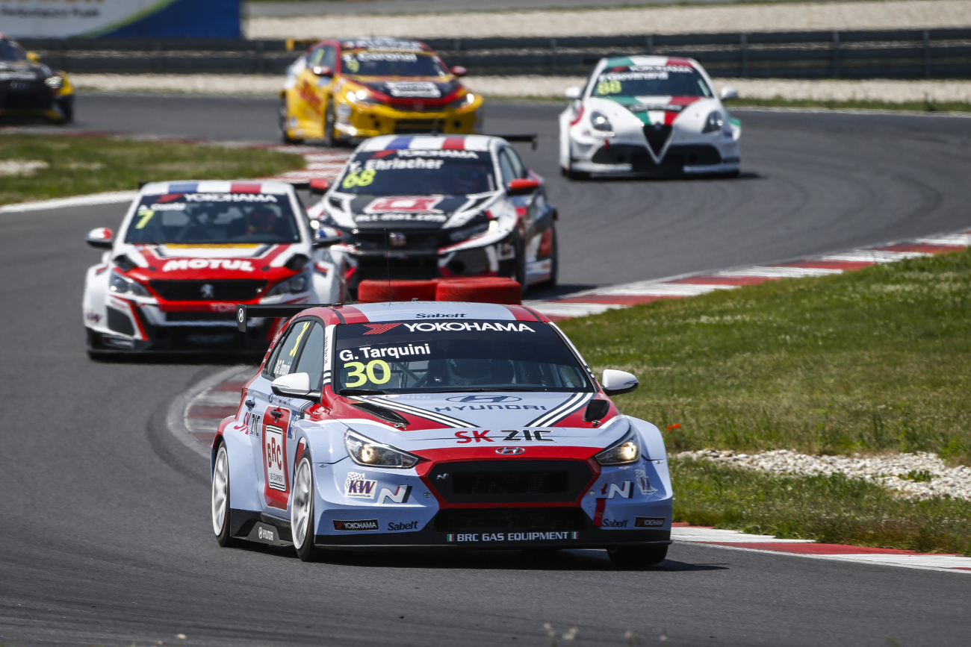

*Tarquini leads the FIA WTCR Series Photo Francois Flamand DPPI*

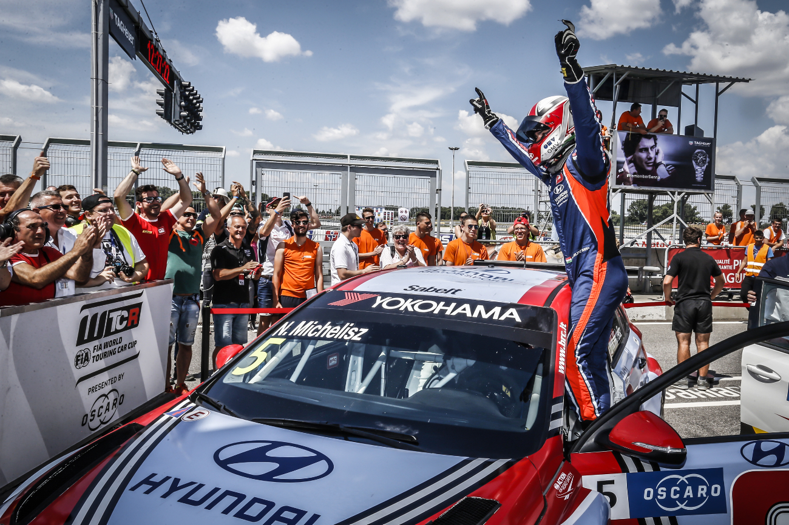

*Michelisz celebrates victory in Slovakia Photo Francois Flamand DPPI*